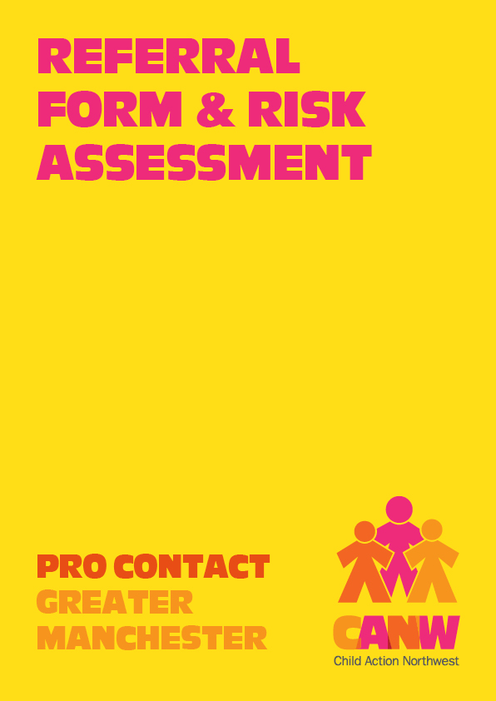

Supported Contact/ Handovers Referral Form
Referrer Information (The ‘referrer’ is the person completing this form). Each parent needs to complete a separate referral form.

Referrer name and role:

Referrer address and postcode:
Telephone:
Email:

Please return your completed form to ProContact@canw.org.uk We may not accept this referral or we may ask for further information regarding this referral. For further information please visit out website - Pro Contact - CANW | Child Action North West

Contact Details

Family Details Child(ren)
Name(s) | Age | Date of Birth | Gender | Ethnicity
Who does the child live with?
Who has parental responsibility?

Adult with Whom the Child Lives
Name:
Relationship to child(ren):
Address:
Postcode: |  | Ethnicity:
Telephone: |  | Email:

Partner
Does the adult with whom the child lives with have a live in partner?
Name:

Adult with Whom the Child Does Not Live
Name:
Relationship to child(ren):
Address:
Postcode: |  | Ethnicity:
Telephone: |  | Email:
Partner
Does the adult with whom the child does not live have a live in partner?
Name:

Solicitors

Adult with Whom the Child Lives
Solicitor’s Name:
Practice:
Address:
Postcode:
Email:
Telephone: |  | Mobile:

Adult with Whom the Child Does Not Live
Solicitor’s Name:
Practice:
Address:
Postcode:
Email:
Telephone: |  | Mobile:

Communication Method

In order for a referral to this service to be accepted, parents must have a co-parenting communication method, eg a parenting app such as our family wizard
What is the method of co-parenting communication?

Cafcass
Is there an allocated Cafcass officer?
Name and address of allocated Cafcass officer:

Have Cafcass made previous recommendations for this family?
What were the recommendations?

Service required | Please tick
Supported Contact
Supported Handover

Proposals for Sessions

Preferred start date to commence:
(Please see 2023/4 session dates)

Who will bring/collect the child/ren?

Are the parents willing to meet?
If the parents and other adults involved in the sessions are not willing to meet please indicate why (court orders, domestic abuse etc).

Are any other adults and or child(ren) allowed to be in the sessions?
Names of adults:
Relationship to child(ren):
Names of child(ren):
Relationship to child(ren):

What is the overall aim of the sessions?

What are the adults’ views / expectations of referral:

What are the children’s views / expectations of referral:

Previous Contact
When and where did contact last take place? Who was involved in this contact?

Why did it break down (if applicable)?

Has this family ever used another centre?

Name of centre and dates used:

Why did the contact end at this centre?

Other Information

Health
Do any of the children or adults involved in the sessions have any special needs or requirements relating to illness, impairment, allergies, special needs or other? (please specify)
Children:
Adults:

Diversity needs
Are there any specific diversity needs?
If yes please specify below

Language/interpreter requirements
Will an interpreter be required?
(Only professional interpreters can be used)
Language spoken:
Who will provide and pay for the interpreter?

Background Details
Court Orders

Is there a court order for this referral?
Name(s) of child(ren) or adult(s) to whom the order relates:

Type of order (child arrangement, care, residence, contact, parental responsibility, specific issues, prohibited steps, injunctions or other), please specify:

Court making order:

Date order made:

Date of next court hearing:

Previous Convictions / Findings of Fact
Please give full details of any offences or findings of fact involving children, domestic abuse, sexual offences, drugs, arson and firearms.
Name of adult to whom conviction/ FoF relates:
Nature of conviction:
Details of conviction:
Date of conviction:

Local Authority Involvement
Does one or more local authority Children’s Services Departments know the family? Present or Historical involvement.
Name of authority:
Name of worker:
Child(ren) involved:
Nature of involvement:
Dates of involvement:

Are any of the children involved in the sessions currently subject to a Child Protection Plan or other Local Authority involvement?
Child(ren)’s name(s):
Category:
Date registered:
Date of next conference:

Are any of the children involved in the proposed CCI currently on the Educational Special Needs Register?
Child(ren)’s name(s):
Specific behavioural/learning difficulties:

Date registered:

What other agencies are the family known to and or been involved with?
Name of agency:
Name of worker:
Nature of involvement:
Dates of involvement:

Risk Assessment
Please provide further detail and information regarding Risk Assessment if Yes/Allegation has been identified and complete all sections.

Please indicate which of the following have affected or are continuing to affect the family you are referring and what is the current level of risk:
Safeguarding children | Yes/No/Allegation | Please indicate
 |  | High | Low | None
Physical Abuse:
Sexual Abuse:
Emotional Abuse:
Neglect:
Risk of Abduction:
Other potential concerns
Domestic abuse:
Conflict between adults:
Alcohol abuse:
Drug/substance abuse:
Mental health issues:
Cultural issues:
Religious issues:
Immigration / asylum:
Financial issues:
Medical condition adult/child:
Physical impairments adult/child:
Learning difficulties adult/child:
Parenting skills:
Involvement of other family members in the contact:
Risk of violence towards staff:
Risk of volatile behaviour:
Risk of self harm:
Other (please specify):

Further detail and information regarding Risk Assessment:

Finance

Referral fee | £165 and non-refundable.  The referral fee is required upon receipt of the referral.  Includes Contact Agreement Meeting with both parents and a child pre-visit (if applicable). These take place via video link.
Supported Contact | £40 per session.  Sessions take place fortnightly at CANW Bolton on Saturdays  09.00-10.45, with staggered arrival and departure times so that parents do not meet.  Visiting parents attend 08.45-11.00.
Supported Handovers | £30 per session.  Sessions take place fortnightly at CANW Bolton on Saturdays and handovers can occur either 09.00-10.45 or 09.00-14.00.  Visting parents 08.45-11.00 or 08.45-14.15.

As a charity, we rely on prompt payment and will not undertake any work until payment is received. Payment needs to be received by 9am one week before each appointment. If appointments are on a weekend, payment must be received by 9am on the Friday, one week before. Please note we will cancel sessions if payment is not received on time and will close the case if prompt payment is an issue so that we can offer the place to another family.

Payment is made as follows:
Bank Transfer Account Name: Child Action Northwest
Sort Code: 05-02-52
Account Number: 22738925
Bank: Yorkshire Bank (Virgin Money)
Your Reference: Your Full Name
Name of person who will be paying for the service:

